MINISTRY OF EDUCATION ANDTRAINING

IRepair

Software Requirement Specification

Project Code: IR.3000

Document Code: DIR.10

* **Ho Chi Minh, 25/01/2021 -**

Record of change

*A - Added M - Modified D - Deleted

|  |  |  |  |  |
| --- | --- | --- | --- | --- |
| Effective Date | Changed Items | A* M, D | Change Description | New Version |
| 25/01/2021 | Initial | a | Add project over view |  |
|  |  |  |  |  |
|  |  |  |  |  |
|  |  |  |  |  |
|  |  |  |  |  |
|  |  |  |  |  |
|  |  |  |  |  |
|  |  |  |  |  |
|  |  |  |  |  |
|  |  |  |  |  |
|  |  |  |  |  |
|  |  |  |  |  |
|  |  |  |  |  |
|  |  |  |  |  |
|  |  |  |  |  |
|  |  |  |  |  |
|  |  |  |  |  |
|  |  |  |  |  |
|  |  |  |  |  |
|  |  |  |  |  |
|  |  |  |  |  |

SIGNATURE PAGE

**ORIGINATOR:** Nguyen Xuan Khanh Hoa 25/01/2020

<Position>

**REVIEWERS:** <Name> <Date>

<Position>

<Name, if it’s needed> <Date>

<Position>

**APPROVAL:** <Name> <Date>

<Position>

TABLE OF CONTENTS

1 Introduction 6

1.1 Purpose 6

1.2 Scope 6

1.3 Definitions, Acronyms, and Abbreviations 6

1.4 References 6

1.5 Overview 6

2 Overall Description 7

2.1 Product Perspective 7

2.2 Product features 7

2.3 Operating environment 9

3 FUNCTIONAL Requirements 10

3.1 Use Cases Diagram 10

3.2 Register 10

3.3 View Profile 12

3.4 Edit Profile 14

3.5 View the repairer’s information 16

3.6 Report problem 18

3.7 View order history 20

3.8 View detail of an order 22

3.9 Accept order 24

3.10 Login 25

3.11 Search a repairer 27

3.12 Remove a repairer 29

3.13 Rate repairer 31

3.14 Search the repair service 33

3.15 View the repair service information 35

3.16 View news 36

3.17 Book repairer 38

3.18 View the specific order 40

3.19 View list of current orders 42

3.20 View detail of a current order 44

3.21 View the list of suggested orders 47

3.22 Cancel booking 49

3.23 Logout 51

3.24 Post a new 53

3.25 Remove a news 55

3.26 Update a news 57

3.27 Ban a repairer 59

3.28 Warn a repairer 60

3.29 Cancel order 62

3.30 Reject order 64

4 NON-FUNCTIONAL Requirements 66

4.1 Usability 66

4.2 Reliability 66

4.3 Performance 66

4.4 Supportability 66

4.5 Design Constraints 66

5 Supporting Information 67

# Introduction

The IRepair is an application that helps users find repairers easily and vice versa.

User can quickly find and select a suitable repairer with the reasonable prices. Besides, the repairer has more customers and increase his/her income.

This software provides a clean and user-friendly interface for the users.

## Purpose

The purpose of thisapplicationis to help user find repairers easily and vice versa.

## Scope

The IRepair designed to run on mobile phone.

The user can book repairer by providing his/her problem, search the direct repair service/repairer and book repairer directly, Besides, the user can cancel the booking and rate the repairer.

The repairer can choose the repaired order, cancel and reject it.

## Definitions, Acronyms, and Abbreviations

IRepair: The name of the application

Repairer: a person that is paid to repair things

SRS: Software Requirement Specification

## References

## Overview

The rest of this SRS contains the following information:

* Overall Description
* Functional Requirements
* Non-functional Requirements
* Supporting Information

# Overall Description

## Product Perspective

A distributed booking repairer database system stores the following information:

* **Repairer detail:**

It includes repairer code, name, address and phone number…. This information may be used for keeping the records of the repairer for any emergency or for any other kind of information.

* **Customer description:**

It includes customer code, name, address and phone number…. This information may be used for keeping the records of the customer for any emergency or for any other kind of information.

* **Booking description:**

It includes customer details, code number, repairer number, date of booking, status.

## Product features

The major features of booking repairer database system are shown in below entity-relationship model (ERD)

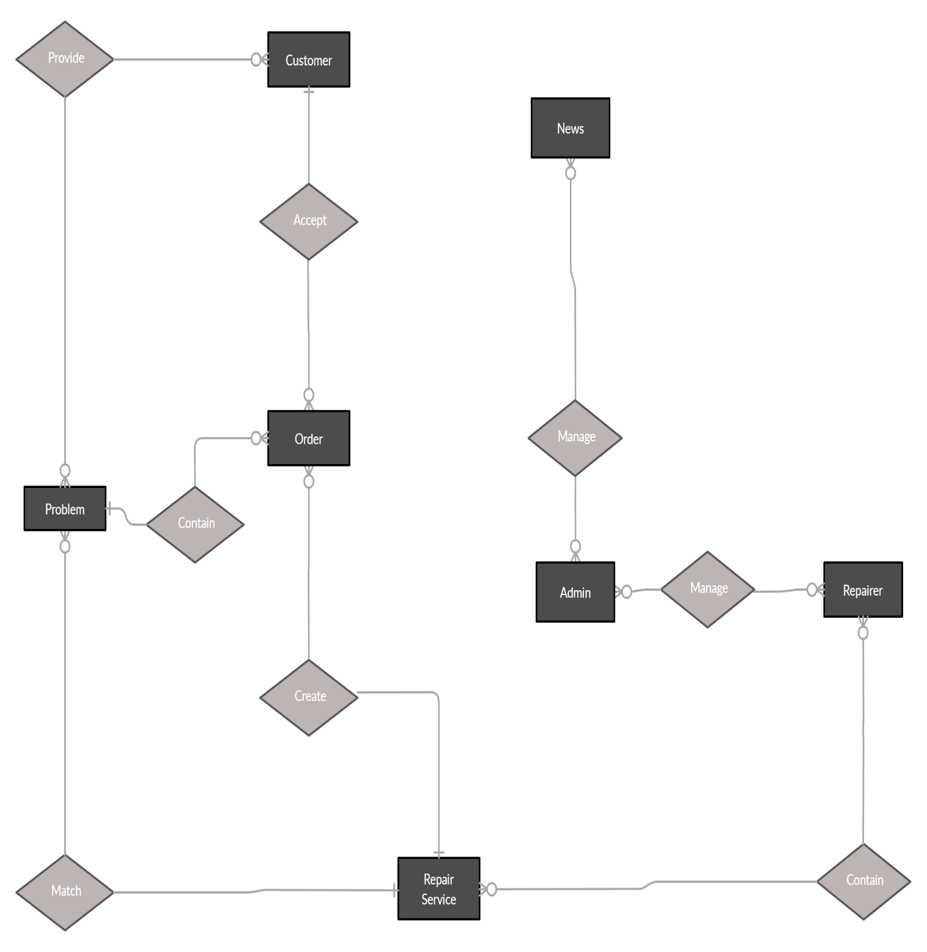

## Operating environment

Operating environment for the booking repairer management system is listed below.

* Client/server system
* Operating system: Android, IOS.
* Database: SQL server
* Platform: vb.net/Java/PHP

# FUNCTIONAL Requirements

## Use Cases Diagram

## Register

|  |  |  |  |
| --- | --- | --- | --- |
|  | Register |  |  |
| USE-UC001 | | | |
| Use Case No. | UC001 | Use Case Version | 1 |
| Use Case Name | Register | | |
| Author | Nguyen Xuan Khanh Hoa | | |
| Date | 20-01-2021 | Priority | Normal |
| Actor: - Guest Summary: - This use case allows guest to register to the system. Goal: - Guest can register to the system. Triggers: - Guess touches “Register” button. Precondition: N/A Post Conditions: - Success: Guess register an account to the system successfully. Show register successfully message. Main Success Scenario: | | | |
| Step | Actor Action | System Response | |
| 1 | Guess goes to register view (Guess registers to become a customer)  [Alternative 1] | System requires identity information from Guest:   * Name: textbox, required * Telephone Number: textbox, required * Address: textbox, required * Password: textbox, required | |
| 2 | Guess inputs information |  | |
| 3 | Guess touches “Register” | Show message “Register successfully” | |
| Alternative Scenario: | | | |
| Step | Actor Action | System Response | |
| 1 | Guess goes to register view (Guess registers to become a repairer) | System requires identity information from Guest:   * Name: textbox, required * Telephone Number: textbox, required * Repaired Major: textbox, required * Description: textbox, required * Password: textbox, required | |
| 2 | Password has been already in the system | The system shows message “The password is existed. Enter another password”. | |
| Exceptions: | | | |
| Step | Actor Action | System Response | |
| 1 |  | System show message the "System is busy" when the internet is lost | |
| Relationships: N/A | | | |
| Business Rules: - Password is encrypted before being sent to system. - New customer/repairer account will be created in the system with inputted information. | | | |

## View Profile

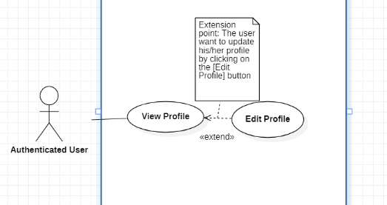

|  |  |  |  |  |  |
| --- | --- | --- | --- | --- | --- |
|  | View Profile | |  | |  |
| USE-UC002 | | | | | |
| Use Case No. | UC002 | | Use Case Version | | 1 |
| Use Case Name | View Profile | | | | |
| Author | Nguyen Xuan Khanh Hoa | | | | |
| Date | 26-01-2021 | | Priority | | Normal |
| Actor: - Authenticated User Summary: - This use case allows user to view his/her profile Goal: - User can view profile. Triggers: - User touches on "View Profile" to view his/her profile. Precondition:  - User must login into the system. Post Conditions: - Success: Show profile of user. Main Success Scenario: | | | | | |
| Step | Actor Action | | System Response | | |
| 1 | User (user is customer) touches on "View Profile"  [Alternative 1] | | System shows user's profile that contains following information: - Name - Telephone Number - Address | | |
| Alternative Scenario: | | | | | |
| Step | | Actor Action | | System Response | |
| 1 | | User (user is repairer) touches on "View Profile" | | System shows user's profile that contains following information: - Name - Telephone Number - Repairer Major   * Description | |
| Exceptions: | | | | | |
| Step | Actor Action | | System Response | | |
| 1 |  | | System show message the "System is busy" when the internet is lost | | |
| Relationships: Edit Profile | | | | | |
| Business Rules:  - The customer’s profile view has following information: name, telephone number, address.  - The repairer’s profile view has following information: name, telephone number, repairer major.  - System show user’s information from database | | | | | |

## Edit Profile

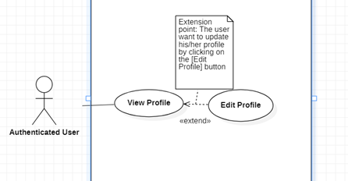

|  |  |  |  |
| --- | --- | --- | --- |
| USE-UC003 | | | |
| Use Case No. | UC003 | Use Case Version | 1.0 |
| Use Case Name | Edit profile | | |
| Author | Nguyen Xuan Khanh Hoa | | |
| Date | 26/02/2021 | Priority | Normal |
| Actor: - Authenticated User Summary: - This use case helps user edit profile Goal: - User can edit profile Triggers: - User touches on “Edit Profile” Precondition: - User must login to the system  - User touches on “View Profile” Post Conditions: - Success: User updates profile successfully. The system shows message “Update profile successfully”. Main Success Scenario: | | | |
| Step | Actor Action | System Response | |
| 1 | User touches on “View profile” | Show the profile | |
| 2 | User touches “Edit profile” (user is customer)  [Alternative 1] | Show editable table including information:   * Name: required textbox * Telephone Number: required textbox * Address: required textbox * Password: required textbox | |
| 3 | User edits information |  | |
| 4 | User chooses "Save" option  [Alternative 2] | * New profile information updated in database. * Show message: “Update profile successfully” | |
| Alternative Scenario: | | | |
| Step | Actor Action | System Response | |
| 1 | User touches “Edit profile” (user is repairer) | Show editable table including information:   * Name: required textbox * Telephone Number: required textbox * Required Major: required textbox * Description: required textbox * Password: required textbox | |
| 2 | User chooses "Save" option but some of required textbox is null | Show message “This field is not null” | |
| Exceptions: | | | |
| Step | Actor Action | System Response | |
| 1 |  | System show message the "System is busy" when the internet is lost | |
| Relationships: View Profile  Business Rules: - User must be login to app before use this function   * Password is encrypted before being sent to system * System updates new user's information in database | | | |

## View the repairer’s information

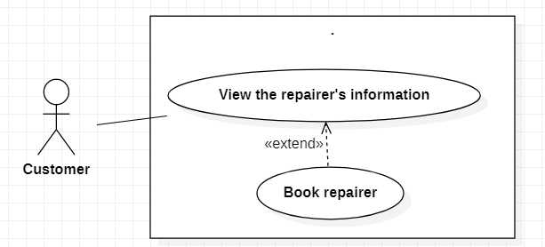

|  |  |  |  |
| --- | --- | --- | --- |
| USE-UC004 | | | |
| Use Case No. | UC004 | Use Case Version | 1.0 |
| Use Case Name | View repairer's information | | |
| Author | Nguyen Xuan Khanh Hoa | | |
| Date | 30/01/2021 | Priority | Normal |
| Actor: - Customer Summary: - This use case helps customer view repairer's information Goal: - Customer can view repairer's information Triggers: - Customer chooses a specific repairer in the list Precondition: - Customer must login to the system Post Conditions: - Success: Show repairer’s information Main Success Scenario: | | | |
| Step | Actor Action | System Response | |
| 1 | Customer touches on the list of repairers | Display the list of repairers | |
| 2 | Customer touches on a specific repairer | Show repairer's information which contains:   * Name * Telephone Number * Repaired Major * Description | |
| Alternative Scenario: N/A | | | |
| Exceptions: | | | |
| Step | Actor Action | System Response | |
| 1 |  | System show message the "System is busy" when the internet is lost | |
| Relationships: Book repairer  Business Rules: - This function is only for Customer - System shows repairer info from database | | | |

## Report problem

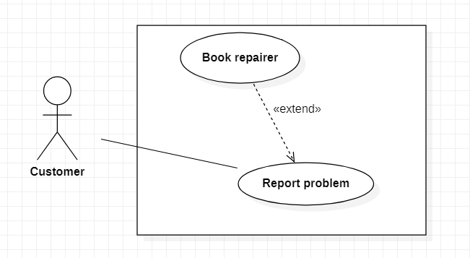

|  |  |  |  |
| --- | --- | --- | --- |
| USE-UC005 | | | |
| Use Case No. | UC005 | Use Case Version | 1.0 |
| Use Case Name | Report problem | | |
| Author | Nguyen Xuan Khanh Hoa | | |
| Date | 30/01/2021 | Priority | High |
| Actor: - Customer Summary: - This use case helps customer give information about problem that needs repairing to the system Goal: - Customer can report problem Triggers: - Customer touches on “Report Problem” Precondition: - Customer must login into the system Post Conditions: - Success: System suggests repairer that can solve customer’s problem Main Success Scenario: | | | |
| Step | Actor Action | System Response | |
| 1 | Customer touches on “Report problem” | Display the report problem view that includes information:   * Problem info: textbox * Problem image: camera image | |
| 2 | Customer provide information about problem by input problem info/send problem image |  | |
| 3 | Customer touches on “Report” button  [Alternative 1] | System records that problem  System redirects to book view | |
| Alternative Scenario: | | | |
| Step | Actor Action | System Response | |
| 1 | Both problem info and problem image are null | Show message “Problem information is empty” | |
| Exceptions: | | | |
| Step | Actor Action | System Response | |
| 1 |  | System show message the "System is busy" when the internet is lost | |
| Relationships: Book repairer  Business Rules:   * Customer must input problem info or send image problem * Problem info not rather than 2000 words | | | |

## View order history

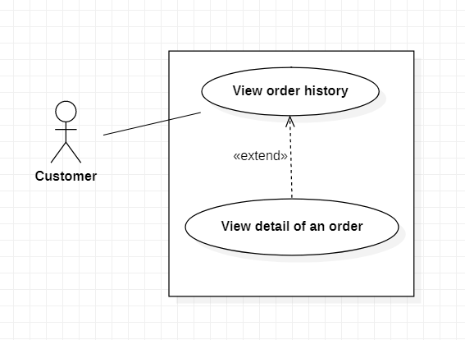

|  |  |  |  |
| --- | --- | --- | --- |
| USE-UC006 | | | |
| Use Case No. | UC006 | Use Case Version | 1.0 |
| Use Case Name | View order history | | |
| Author | Nguyen Xuan Khanh Hoa | | |
| Date | 30/01/2021 | Priority | Normal |
| Actor: - Customer Summary: - This use case helps customer view order history  Goal: - Customer can view order history Triggers: - Customer touches on “Order history” Precondition: - Customer must login into the system Post Conditions: - Success: System shows the list of orders that are done. Main Success Scenario: | | | |
| Step | Actor Action | System Response | |
| 1 | Customer touches on “Order history”  [Alternative 1] | Show the list of orders which are done | |
| Alternative Scenario: | | | |
| Step | Actor Action | System Response | |
| 1 | Customer touches on “Order history” but customer has not booking before | Show message “You don’t have any order” | |
| Exceptions: | | | |
| Step | Actor Action | System Response | |
| 1 |  | System show message the "System is busy" when the internet is lost | |
| Relationships: View detail of an order  Business Rules: - This function is only for Customer   * If customer hasn’t book repairer before, there is no order to view | | | |

## View detail of an order



|  |  |  |  |
| --- | --- | --- | --- |
| USE-UC007 | | | |
| Use Case No. | UC007 | Use Case Version | 1.0 |
| Use Case Name | View detail of an order | | |
| Author | Nguyen Xuan Khanh Hoa | | |
| Date | 30/01/2021 | Priority | Normal |
| Actor: - Customer Summary: - This use case helps customer view detail of an order  Goal: - Customer can view detail of an order Triggers: - Customer touches on an order in the order history Precondition: - Customer must login into the system   * Customer touches on “Order history” to view list of order   Post Conditions: - Success: System shows detail of an order  Main Success Scenario: | | | |
| Step | Actor Action | System Response | |
| 1 | Customer touches on “Order history”  [Alternative 1] | Show the list of orders which are done | |
| 2 | Customer touches on an order | Show detail of order:   * Problem name * Repairer * Repair Service * Date * Repairer Rate | |
| Alternative Scenario: | | | |
| Step | Actor Action | System Response | |
| 1 | Customer touches on “Order history” but customer has not booking before | Show message “You don’t have any order” | |
| Exceptions: | | | |
| Step | Actor Action | System Response | |
| 1 |  | System show message the "System is busy" when the internet is lost | |
| Relationships: View order history  Business Rules: - This function is only for Customer   * If customer hasn’t book repairer before, there is no order to view | | | |

## Accept order

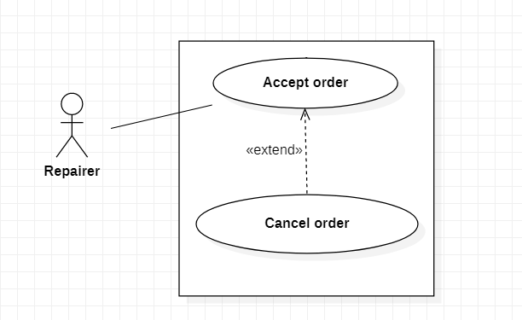

|  |  |  |  |
| --- | --- | --- | --- |
| USE-UC008 | | | |
| Use Case No. | UC008 | Use Case Version | 1.0 |
| Use Case Name | Accept order | | |
| Author | Nguyen Xuan Khanh Hoa | | |
| Date | 30/01/2021 | Priority | High |
| Actor: - Repairer Summary: - This use case helps repairer accept an order  Goal: - Repairer can accept order Triggers: - Repairer touches on “Accept order” Precondition: - Repairer must login into the system  Post Conditions: - Success: An order is accepted  Main Success Scenario: | | | |
| Step | Actor Action | System Response | |
| 1 | Repairer is on the order view  [Alternative 1] | Show the list of orders | |
| 2 | Repairer touches on “Accept order” on the line of an order | System show message “The order is accepted” | |
| Alternative Scenario: | | | |
| Step | Actor Action | System Response | |
| 1 | Repairer is on the order view but there is no order | Show message “Now you don’t have any suggest order” | |
| Exceptions: | | | |
| Step | Actor Action | System Response | |
| 1 |  | System show message the "System is busy" when the internet is lost | |
| Relationships: Cancel order  Business Rules: - Repairer can only accept an order when does not have any other order | | | |

## Login

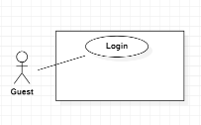

|  |  |  |  |
| --- | --- | --- | --- |
| USE-UC009 | | | |
| Use Case No. | UC009 | Use Case Version | 1.0 |
| Use Case Name | Login | | |
| Author | ChauVM | | |
| Date | 21/01/2021 | Priority | Low |
| Actor: - Guest Summary: - This use case allows guest to log in the system Goal: - Guest can log in the system Triggers: - Guest choose "Login" option  Precondition: - N/A Post Conditions: - Success: Guest login the system Main Success Scenario: | | | |
| Step | Actor Action | System Response | |
| 1 | Guest goes to login view | System requires identity information form Guest:  - Email or user code: free text input  - Password: free text input | |
| 2 | Guest inputs information |  | |
| 3 | Guest sends command to login to system | Guest will login system with their specific role [Alternative 1] [Exception 1] | |
| Alternative Scenario: | | | |
| Step | Actor Action | System Response | |
| 1 | Guest enter wrong identity information | Wrong identity information, System shows error message | |
| Exception: | | | |
| Step | Actor Action | System Response | |
| 1 |  | System show message “No Internet connection please try again later” when the internet is lost | |
| Relationships: N/A Business Rules: - Password are encrypted before being sent to server - After login to system, guest will redirect to specific view based on their role on the system: repairer or customer - If role is “Customer”, the system will display to Customer view - If role is “Repairer”, the system will display to Repairer view | | | |

## Search a repairer

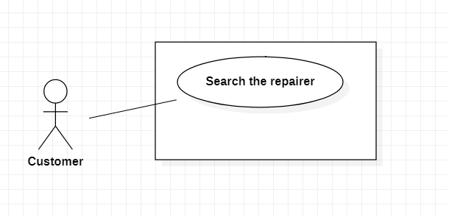

|  |  |  |  |
| --- | --- | --- | --- |
|  | Search the repairer |  |  |
| USE-UC010 | | | |
| Use Case No. | UC010 | Use Case Version | 1.0 |
| Use Case Name | Search the repairer | | |
| Author | ChauVM | | |
| Date | 20/01/2021 | Priority | Medium |
| Actor: - Customer Summary: - This use case help customer search repairer Goal: - Customer can search repairer info Triggers: - Customer choose "Search" option Precondition: - Customer must login Post Conditions: - Success: Show repairer's info Main Success Scenario: | | | |
| Step | Actor Action | System Response | |
|  | Customer goes to list of repairers | Display list of repairers | |
| 2 | Customer type repairer name | Display list of repairers have similar name | |
| 2 | Customer choose “Search” option |  | |
| 3 | Customer sends command to system | System will show repairer info [Alternative Scenario 1] [Exception 1] | |
| Alternative Scenario: | | | |
| Step | Actor Action | System Response | |
| 1 |  | System shows similar repairer info | |
| Exceptions: | | | |
| Step | Actor Action | System Response | |
| 1 |  | System show message the "System is busy" when the internet is lost | |
| 2 |  | System show message the "Not found" | |
| Relationships: View the list of repairers Business Rules: - This function is only for Customer - User must be login to app before use this function - Search request will be sent to the system - System show repairer info from database | | | |

## Remove a repairer

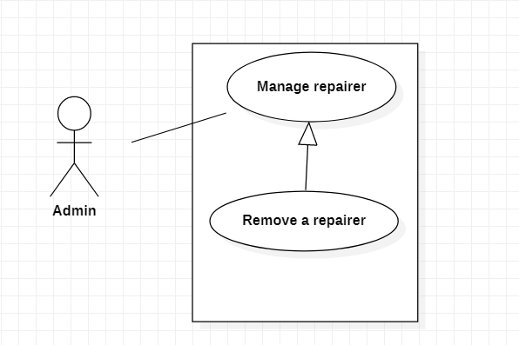

|  |  |  |  |
| --- | --- | --- | --- |
| USE-UC011 | | | |
| Use Case No. | UC011 | Use Case Version | 1.0 |
| Use Case Name | Remove a repairer | | |
| Author | ChauVM | | |
| Date | 20/01/2021 | Priority | High |
| Actor: - Admin Summary: - This use case help admin remove repairer Goal: - Admin can remove a repairer Triggers: - Admin sends request by choosing Remove option Precondition: - User must login in role "Admin" Post Conditions: - Success: Send the remove request Main Success Scenario: | | | |
| Step | Actor Action | System Response | |
| 1 | Admin goes to repairer info | Display repairer info | |
| 2 | Admin choose “Remove” option | The system will return 2 cases: - Show the profile screen - Show error message | |
| 3 | Admin sends command to system | System will remove repairer from database  [Exception 1] | |
| Alternative Scenario: N/A | | | |
| Exceptions: | | | |
| Step | Actor Action | System Response | |
| 1 |  | System show message the "System is busy" when the internet is lost | |
| Relationships: N/A Business Rules: -This function is only for Admin - User must be login to app before use this function - Remove request will be sent to the system - System remove repairer info from database - A message will be shown after the process is completed | | | |

## Rate repairer

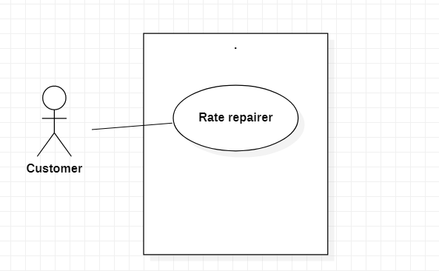

|  |  |  |  |
| --- | --- | --- | --- |
|  | Rate repairer |  |  |
| USE-UC012 | | | |
| Use Case No. | UC012 | Use Case Version | 1.0 |
| Use Case Name | Rate repairer | | |
| Author | ChauVM | | |
| Date | 20/01/2021 | Priority | Low |
| Actor: - Customer Summary: - This use case help customer rate a repairer Goal: - Customer can give their comment about a repairer Triggers: - Customer choose "Rate" option Precondition: - Customer login to system  Post Conditions: - Success: Send report request to Admin Main Success Scenario: | | | |
| Step | Actor Action | System Response | |
| 1 | Customer goes to repairer info | Display repairer info | |
| 2 | Customer chooses “Rate” option | Display new view require user input some information: - Choose from 1 star to 5 stars - Comment: free text input, required, length 1 - 250 | |
| 3 | Customer inputs information |  | |
| 4 | Customer sends report request to system | Send request to system [Exception 1] | |
| Alternative Scenario: N/A | | | |
| Exceptions: | | | |
| Step | Actor Action | System Response | |
| 1 | User didn’t put any information | Show message to notify user that they have to input information | |
| 2 |  | System show message the "System is busy" when the internet is lost | |
| Relationships: N/A Business Rules: - Rate request will be sent with inputted information - A message will be shown after the process is completed | | | |

## Search the repair service

|  |  |  |  |
| --- | --- | --- | --- |
| USE-UC013 | | | |
| Use Case No. | UC013 | Use Case Version | 1.0 |
| Use Case Name | Search the repair service | | |
| Author | ChauVM | | |
| Date | 04/03/2021 | Priority | Medium |
| Actor: - Customer Summary: - This use case help customer search repair service Goal: - Customer can search repair service Triggers: - Customer choose "Search" option Precondition: - User must be Customer Post Conditions: - Success: Show repair service available Main Success Scenario: | | | |
| Step | Actor Action | System Response | |
|  | Customer goes to list of repair services | Display list of repair service | |
| 2 | Customer type repair service's name or problem | Display list of repair service have similar name or suitable to Customer's problem | |
| 2 | Customer choose “Search” option |  | |
| 3 | Customer sends command to system | System will show repair service [Alternative Scenario 1] [Exception 1] | |
| Alternative Scenario: | | | |
| Step | Actor Action | System Response | |
| 1 |  | System shows similar repair service | |
| Exceptions: | | | |
| Step | Actor Action | System Response | |
| 1 |  | System show message the "System is busy" when the internet is lost | |
| 2 |  | System show message the "Not found" | |
| Relationships: N/A Business Rules: - This function is only for Customer - User must be login to app before use this function - Search request will be sent to the system - System show repair service info from database | | | |

## View the repair service information

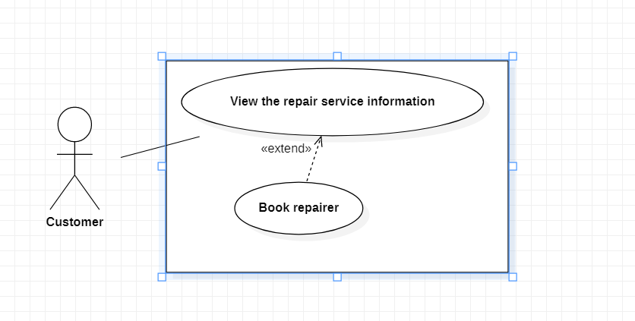

|  |  |  |  |
| --- | --- | --- | --- |
| USE-UC014 | | | |
| Use Case No. | UC014 | Use Case Version | 1.0 |
| Use Case Name | View repair service information | | |
| Author | ChauVM | | |
| Date | 03/03/2021 | Priority | Low |
| Actor: - Customer Summary: - This use case allows customer to view repair service information Goal: - Customer can view repair service information Triggers: - Customer press on a specific repair service Precondition: - User must be Customer  Post Conditions: - Success: System show details of repair service Main Success Scenario: | | | |
| Step | Actor Action | System Response | |
| 1 | Customer press on service category | System shows the list of repair service | |
| 2 | Customer press on a repair service | System shows details of repair service [Exception 1] | |
| Alternative Scenario: N/A | | | |
| Exception: | | | |
| Step | Actor Action | System Response | |
| 1 |  | System show message “No Internet connection please try again later” when the internet is lost | |
| Relationships: Book repairer Business Rules: - This function is only for Customer - User must be login to app with the role Customer before use this function - This function only show valid services | | | |

## View news

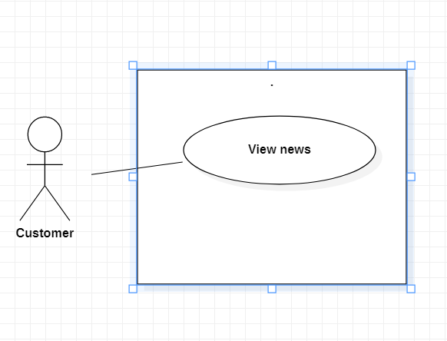

|  |  |  |  |
| --- | --- | --- | --- |
| USE-UC015 | | | |
| Use Case No. | UC015 | Use Case Version | 1.0 |
| Use Case Name | View news | | |
| Author | ChauVM | | |
| Date | 04/03/2021 | Priority | Medium |
| Actor: - Customer Summary: - This use case help Customer view news post by Admin Goal: - Customer can view news Triggers: - Customer press on the news Precondition: - User must be Customer Post Conditions: - Success: Show the news details Main Success Scenario: | | | |
| Step | Actor Action | System Response | |
| 1 | Customer goes to list of news | Display list of news | |
| 2 | Customer press on a news | Display news details [Exception 1] | |
| Alternative Scenario: N/A | | | |
| Exceptions: | | | |
| Step | Actor Action | System Response | |
| 1 |  | System show message the "System is busy" when the internet is lost | |
| Relationships: N/A Business Rules: - This function can be use by both Customer and Admin - User must be login to app before use this function - System show news details from database | | | |

## Book repairer

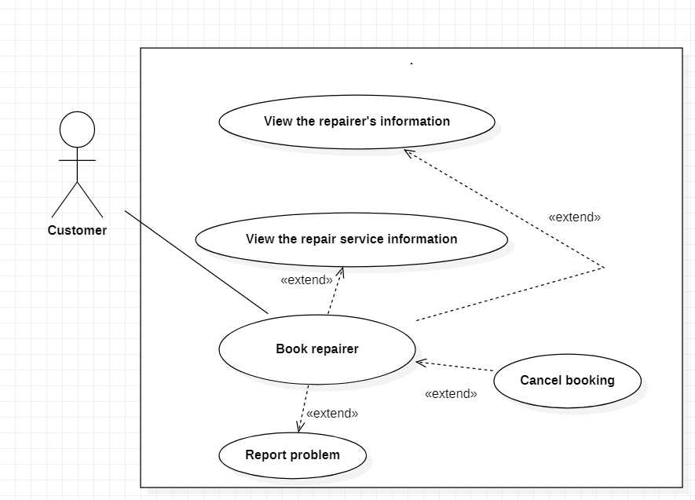

|  |  |  |  |
| --- | --- | --- | --- |
|  | Book Repairer |  |  |
| USE-UC016 | | | |
| Use Case No. | UC016 | Use Case Version | 1.0 |
| Use Case Name | Book repairer | | |
| Author | ThiLK | | |
| Date | 15/01/2021 | Priority | High |
| Actor: - Customer Summary: - Help customer to book repairer Goal: - Customer can book a repairman Triggers: - Customer touches on “Report” button Precondition: - Customer must login.  - Customer report problem. Post Conditions: - Success: Customer book repairer successful. Main Success Scenario: | | | |
| Step | Actor Action | System Response | |
| 1 | Customer touches on “Report” button | System redirects to book view with following order reception info:   * Problem information * Repair Service information * Price * Payment method | |
| 2 | Customer choose payment method, add discount. |  | |
| 3 | Customer press “Book”  <Exception 2> | * System matches a suitable repairer with the customer. * System record order reception into database. * System shows message “On-going”   <Alternative 1> | |
| Alternative Scenario: | | | |
| Step | Actor Action | System Response | |
| 1 |  | If time to find and match repairer with customer is more than 2 hours, system must cancel the booking and show message cannot find suitable repairer in this time. | |
| Exceptions: | | | |
| Step | Actor Action | System Response | |
| 1 |  | System show message the "System is busy" when the internet is lost | |
| 2 |  | If payment failed. Show message to notify user that payment failed and the renew request has been aborted | |
| Relationships: Report problem, View the repairer's information, View the repair service information, Cancel Booking Business Rules:  -The order detail will save to the database - Booking date must not be earlier than the current date.   * If time to find and match repairer with customer is more than 2 hours, system must cancel the booking and show message cannot find suitable repairer in this time. | | | |

## View the specific order

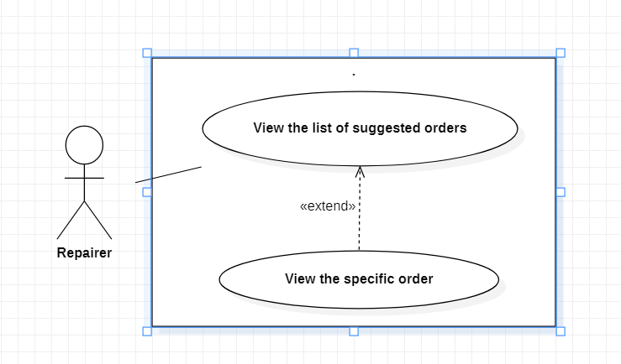

|  |  |  |  |
| --- | --- | --- | --- |
| USE-UC017 | | | |
| Use Case No. | UC017 | Use Case Version | 1 |
| Use Case Name | View the specific order | | |
| Author | ThiLK | | |
| Date | 15/01/2021 | Priority | Normal |
| Actor: | | | |
| -Repairer | | | |
| Summary: | | | |
| -Help repairer to view the specific order | | | |
| Goal: | | | |
| -Show the specific order to repairer | | | |
| Triggers: | | | |
| -Repairer choose the specific order | | | |
| Precondition: | | | |
| -User must be Repairer | | | |
| -The order has not been canceled by the system due to too long time | | | |
| Post Conditions: | | | |
| -Success: Repairer see the specific order | | | |
| Main Success Scenario: | | | |
| Step | Actor Action | System Response | |
|  |  | The system will return 2 cases: | |
| -Show the main screen | |
| -Show login fail message | |
| 2 | Repairer Press view the list of suggested orders | The system will return 2 cases: | |
| -Show the list of suggested orders | |
| - Show error message | |
| 3 | Repairer Press to the specific order | The system will return 2 cases: | |
| -Show the specific order | |
| - Show error message | |
| Alternative Scenario: | | | |
| Step | Actor Action | System Response | |
| 1 | Repair workers are not logged in | The System can’t show the list of suggested orders | |
|  |
| Exceptions: | | | |  |
| Step | Actor Action | System Response | |  |
| 1 |  | System show message the "System is busy" when the internet is lost | |  |
| 2 | Repairer don’t have any orders | System show message “You don’t have any orders” | |  |
| Relationships: View the list of suggested orders | | | |  |
| Business Rules: | | | |  |
| -User must have at least 1 order | | | |  |
| -This function only shows the valid orders | | | |  |

## View list of current orders

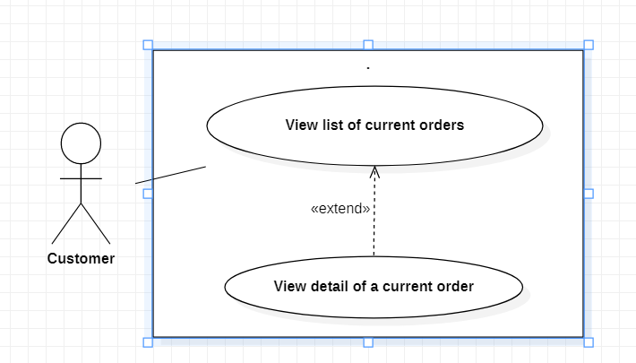

|  |  |  |  |
| --- | --- | --- | --- |
|  | View the List of current order(s) |  |  |
| USE-UC018 | | | |
| Use Case No. | UC018 | Use Case Version | 1.0 |
| Use Case Name | View the list of current orders | | |
| Author | ThiLK | | |
| Date | 15/01/2021 | Priority | High |
| Actor: - Customer Summary: - Help customer to view the list of current orders Goal: - Show the list of current orders to customer Triggers: - Customer press on current orders Precondition: - Customer must login to system - The order has not been canceled by the system due to too long time Post Conditions: - Success: Customer see the list of current orders Main Success Scenario: | | | |
| Step | Actor Action | System Response | |
| 1 | Customer login to the app | The system will return 2 cases: -Show the main screen -Show login fail message | |
| 2 | Customer press on the profile icon | The system will return 2 cases: -Show the profile screen - Show error message | |
| 3 | Customer press on current orders | The system will return 2 cases: -Show the list of current orders - Show error message | |
| Alternative Scenario: | | | |
| Step | Actor Action | System Response | |
| 1 | Customer workers are not logged in | The System can’t show the list of current orders | |
| Exceptions: | | | |
| Step | Actor Action | System Response | |
| 1 |  | System show message the "System is busy" when the internet is lost | |
| 2 | Customer don’t have any orders | System show message “You don’t have any orders” | |
| Relationships: View detail of current order Business Rules: - User must have at least 1 order - This function only shows the valid orders | | | |

## View detail of a current order



|  |  |  |  |
| --- | --- | --- | --- |
| USE-UC019 | | | |
| Use Case No. | UC019 | Use Case Version | 1 |
| Use Case Name | View detail of current order | | |
| Author | ThiLK | | |
| Date | 15/01/2021 | Priority | Normal |
| Actor: | | | |
| -Customer | | | |
| Summary: | | | |
| -Help Customer to view detail of current order | | | |
| Goal: | | | |
| -Show the detail of current order | | | |
| Triggers: | | | |
| - Customer login to the app | | | |
| -Customer presss on the profile icon | | | |
| -Customer presss on show current orders | | | |
| -Customer presss on one current order | | | |
| Precondition: | | | |
| -User must be Customer | | | |
| -The order has not been canceled by the system due to too long time | | | |
| Post Conditions: | | | |
| -Success: Customer see the list of current orders | | | |
| Main Success Scenario: | | | |
| Step | Actor Action | System Response | |
| 1 | Customer login to the app |  | |
| The system will return 2 cases: | |
| -Show the main screen | |
| -Show login fail message | |
| 2 | Customer presss on the profile icon | The system will return 2 cases: | |
| -Show the profile screen | |
| - Show error message | |
| 3 | Customer presss on current orders | The system will return 2 cases: | |
| -Show the list of current orders | |
| - Show error message | |
| 4 | Customer presss on one current order | The system will return 2 cases: | |
| -Show the detail of current order | |
| - Show error message | |
| Alternative Scenario: | | | |
| Step | Actor Action | System Response | |
| 1 | Customer workers are not logged in | The System can’t show the list of current orders | |
|  |
| Exceptions: | | | |  |
| Step | Actor Action | System Response | |  |
| 1 |  | System show message the "System is busy" when the internet is lost | |  |
| 2 | Customer don’t have any orders | System show message “You don’t have any orders” | |  |
| Relationships: View the list of current order(s), Cancel Booking | | | |  |
| Business Rules: | | | |  |
| -This function is only for Customer | | | |  |
| -User must be login to app before use this function | | | |  |
| -User must have at least 1 order | | | |  |
| -This function only shows the valid orders | | | |  |

## View the list of suggested orders



|  |  |  |  |
| --- | --- | --- | --- |
|  | View the List of suggested order(s) |  |  |
| USE-UC020 | | | |
| Use Case No. | UC020 | Use Case Version | 1.0 |
| Use Case Name | View the list of suggested orders | | |
| Author | ThiLK | | |
| Date |  | Priority | High |
| Actor: - Repairer Summary: - Help repairer to view the list of suggested orders Goal: - Show the list of suggested orders to repairer Triggers:  - Repairer press view the list of suggested orders Precondition: - User must be Repairer - The order has not been canceled by the system due to too long time Post Conditions: - Success: Repairer see the list of suggested orders Main Success Scenario: | | | |
| Step | Actor Action | System Response | |
| 1 | Repairer login to the app | The system will return 2 cases: -Show the main screen -Show login fail message | |
| 2 | Repairer Press view the list of suggested orders | The system will return 2 cases: -Show the list of suggested orders - Show error message | |
| Alternative Scenario: | | | |
| Step | Actor Action | System Response | |
| 1 | Repair workers are not logged in | The System can’t show the list of suggested orders | |
| Exceptions: | | | |
| Step | Actor Action | System Response | |
| 1 |  | System show message the "System is busy" when the internet is lost | |
| 2 | Repairer don’t have any orders | System show message “You don’t have any orders” | |
| Relationships: View the specific order | | | |
| Business Rules: -User must have at least 1 order -This function only shows the valid orders | | | |

## Cancel booking



|  |  |  |  |
| --- | --- | --- | --- |
|  | Cancel Booking |  |  |
| USE-UC021 | | | |
| Use Case No. | UC021 | Use Case Version | 1.0 |
| Use Case Name | Cancel Booking | | |
| Author | ThiLK | | |
| Date | 15/01/2021 | Priority | High |
| Actor: - Customer Summary: - Help customer to cancel booking Goal: - Customer cancel booking a repairer  Triggers: -Customer press “Cancel booking” Precondition: - Customer must login to system  - Customer book repairer before Post Conditions: - Success: Customer cancel booking a repairer successful Main Success Scenario: | | | |
| Step | Actor Action | System Response | |
| 1 | Customer is on the list of current orders view  <Alternative 1> |  | |
| 2 | Customer press “Cancel booking” | * System cancels booking * Show message order canceled | |
| Alternative Scenario: | | | |
| Step | Actor Action | System Response | |
| 1 | Customer is on the book view (The system is loading to find the suitable repairer) |  | |
| Exceptions: | | | |
| Step | Actor Action | System Response | |
| 1 |  | System show message the "System is busy" when the internet is lost | |
| Relationships: View the detail of a current orders, Book repairer, Report problem | | | |
| Business Rules: -User must have at least 1 order -This function only shows the valid orders -This function only cancels the valid orders | | | |

## Logout

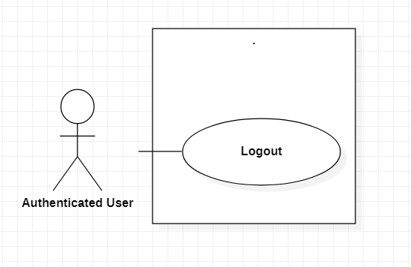

|  |  |  |  |
| --- | --- | --- | --- |
|  | Logout |  |  |
| USE-UC022 | | | |
| Use Case No. | UC022 | Use Case Version | 1.0 |
| Use Case Name | Logout | | |
| Author | ThiLK | | |
| Date | 15/01/2021 | Priority | Normal |
| Actor: - Authenticated User Summary: - Help Authenticated User to logout Goal: - Authenticated User logout the app  Triggers: - Authenticated User press Logout button Precondition: - Guest must be Login Post Conditions: - Success: Authenticated User successful logout the app Main Success Scenario: | | | |
| Step | Actor Action | System Response | |
| 1 | Guest login to the app | The system will return 2 cases: -Show the main screen -Show login fail message | |
| 2 | Authenticated User Press logout button | The system will return 2 cases: -Show logout successful message - Show error message | |
| Alternative Scenario: | | | |
| Step | Actor Action | System Response | |
| 1 | Customer are not logged in | The System can’t show the list of suggested orders | |
| Exceptions: | | | |
| Step | Actor Action | System Response | |
| 1 |  | System show message the "System is busy" when the internet is lost | |
| 2 | Customer didn’t login |  | |
| Relationships: N/A | | | |
| Business Rules: -User must be login to app to use this function | | | |

## Post a new

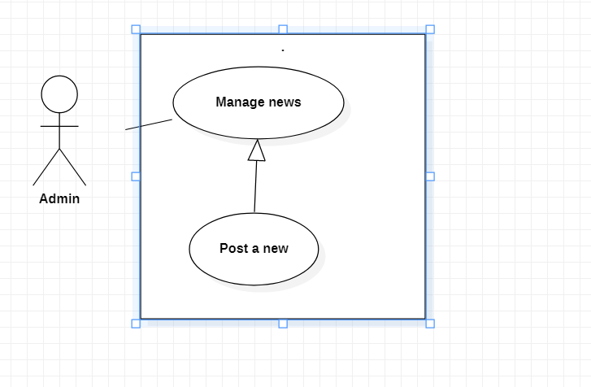

|  |  |  |  |
| --- | --- | --- | --- |
|  | Post a new |  |  |
| USE-UC023 | | | |
| Use Case No. | UC023 | Use Case Version | 1.0 |
| Use Case Name | Post a new | | |
| Author | LongNLT | | |
| Date | 20/01/2021 | Priority | Medium |
| Actor: - Admin Summary: - Post new(s) on the deals and new(s) Goal: - Show the user new deal(s) and new(s) Triggers: - Admin press Post Precondition: - User must be Admin - Deal(s) or New(s) that has been approved. Post Conditions: - Success: A new New/Deals has been uploaded Main Success Scenario: | | | |
| Step | Actor Action | System Response | |
| 1 | Admin presses on the New icon | Display the list of News | |
| 2 | Admin presses Add | Display the format of a new for input | |
| 3 | Admin input the news’ information | System will show if there is any wrong format input | |
| 4 | Admin press Post | Return to the list of news with the new news just added. | |
| Alternative Scenario: | | | |
| Step | Actor Action | System Response | |
| 1 |  | System shows similar repairer info | |
| Exceptions: | | | |
| Step | Actor Action | System Response | |
| 1 |  | System show message the "System is busy" when the internet is lost | |
| 2 |  | System show message the "Not found" | |
| Relationships: N/A Business Rules: - Add request will be sent to the system - System will add the news’ information into database | | | |

## Remove a news

|  |  |  |  |
| --- | --- | --- | --- |
|  | Remove a new |  |  |
| USE-UC024 | | | |
| Use Case No. | UC024 | Use Case Version | 1.0 |
| Use Case Name | Remove a new | | |
| Author | LongNLT | | |
| Date | 21/01/2021 | Priority | Medium |
| Actor: - Admin Summary: - Delete a New Goal: - Delete a wrong or unnecessary new on the New List Triggers: - Admin press Delete Precondition: - User must be Admin Post Conditions: - Success: A new New/Deals will be deleted. Main Success Scenario: | | | |
| Step | Actor Action | System Response | |
| 1 | Admin press on the New icon | Display the list of News | |
| 2 | Admin press on a New | Display the news’ information | |
| 3 | Admin press Delete | System will show a confirm message | |
| 4 | Admin press Agree | Return to the list of news without the deleted new | |
| Alternative Scenario: | | | |
| Step | Actor Action | System Response | |
| 1 |  | System shows other news that is old or unpopular | |
| Exceptions: | | | |
| Step | Actor Action | System Response | |
| 1 |  | System show message the "System is busy" when the internet is lost | |
| 2 |  | System show message the "Not found" | |
| Relationships: N/A Business Rules: - Add request will be sent to the system - System remove the news’ information into database | | | |

## Update a news

|  |  |  |  |
| --- | --- | --- | --- |
|  | Update a New |  |  |
| USE-UC025 | | | |
| Use Case No. | UC025 | Use Case Version | 1.0 |
| Use Case Name | Update a new | | |
| Author | LongNLT | | |
| Date | 21/01/2021 | Priority | Medium |
| Actor: - Admin Summary: - Update a New Goal: - Update the current wrong new Triggers: - Admin press Update Precondition: - User must be Admin Post Conditions: - Success: A new New/Deals will be updated. Main Success Scenario: | | | |
| Step | Actor Action | System Response | |
| 1 | Admin press on the New icon | Display the list of News | |
| 2 | Admin press on a New | Display the news’ information [Exception] | |
| 3 | Admin press Update | System let the Admin to change the news’ information | |
| 4 | Admin press Confirm | [Exception] System will show a confirm dialog | |
| 5 | Admin press Agree | Return to the list of news | |
| Alternative Scenario: | | | |
| Step | Actor Action | System Response | |
| 1 |  | System shows other news | |
| Exceptions: | | | |
| Step | Actor Action | System Response | |
| 1 |  | System show message the "System is busy" when the internet is lost | |
| 2 |  | System show message the "Not found" | |
| Relationships: N/A Business Rules: - Add request will be sent to the system - System update the news’ information into database | | | |

## Ban a repairer

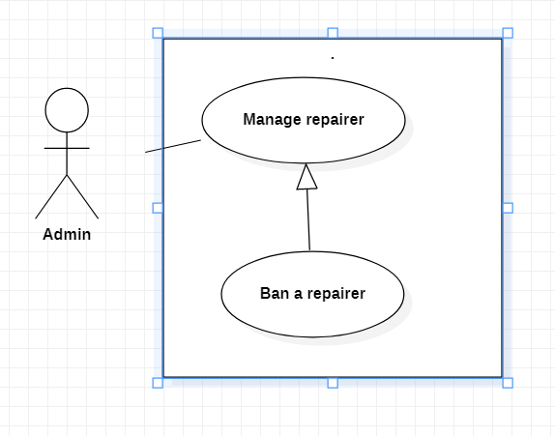

|  |  |  |  |
| --- | --- | --- | --- |
| USE-UC026 | | | |
| Use Case No. | UC026 | Use Case Version | 1.0 |
| Use Case Name | Ban a repairer | | |
| Author | LongNLT | | |
| Date | 22/01/2021 | Priority | High |
| Actor: - Admin Summary: - Ban a repairer Goal: - Ban a mistake making repairer Triggers: - Admin press Ban Precondition: - User must be Admin - Approved repairer's action has happen many time Post Conditions: - Success: A repairer has been Ban. Main Success Scenario: | | | |
| Step | Actor Action | System Response | |
| 1 | Admin search for repairer(s) | Display the list of related repairers | |
| 2 | Admin press on a repairer | Display the repairer's information | |
| 3 | Admin press Ban | Show reason(s) and message to send | |
| 4 | Admin input reason and press confirm | System will show a confirm dialog | |
| 5 | Admin press Agree | Return main page with success message | |
| Alternative Scenario: | | | |
| Step | Actor Action | System Response | |
| 1 |  | System shows another repairer | |
| Exceptions: | | | |
| Step | Actor Action | System Response | |
| 1 |  | System show message the "System is busy" when the internet is lost | |
| 2 |  | System show message the "Not found" | |
| Relationships: N/A Business Rules: - Message request will be sent to the system - System will add the ban's record into database - The current banned repairer will be unactive for a period of time | | | |

## Warn a repairer

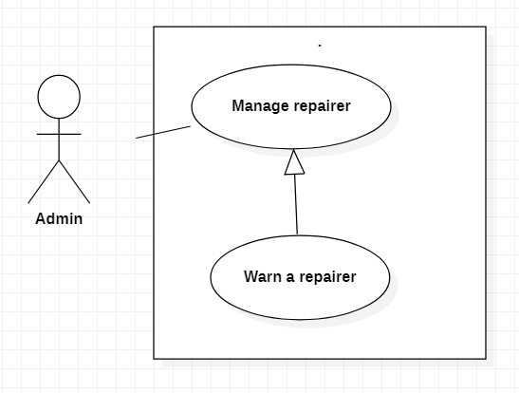

|  |  |  |  |
| --- | --- | --- | --- |
| USE-UC027 | | | |
| Use Case No. | UC027 | Use Case Version | 1.0 |
| Use Case Name | Warn a repairer | | |
| Author | LongNLT | | |
| Date | 22/01/2021 | Priority | Medium |
| Actor: - Admin Summary: - Warn a repairer Goal: - Warn a mistake making repairer Triggers: - Admin press Warn Precondition: - User must be Admin - Approved repairer's action Post Conditions: - Success: A repairer has been warned. Main Success Scenario: | | | |
| Step | Actor Action | System Response | |
| 1 | Admin search for repairer(s) | Display the list of related repairers | |
| 2 | Admin press on a repairer | Display the repairer's information | |
| 3 | Admin press Warn | Show reason(s) and message to send | |
| 4 | Admin input reason and press confirm | System will show a confirm dialog | |
| 5 | Admin press Agree | Return main page with success message | |
| Alternative Scenario: | | | |
| Step | Actor Action | System Response | |
| 1 |  | System shows another repairer | |
| Exceptions: | | | |
| Step | Actor Action | System Response | |
| 1 |  | System show message the "System is busy" when the internet is lost | |
| 2 |  | System show message the "Not found" | |
| Relationships: N/A Business Rules: - Message request will be sent to the system - System will add the warn record into database | | | |

## Cancel order



|  |  |  |  |
| --- | --- | --- | --- |
|  | Cancel Order |  |  |
| USE-UC031 | | | |
| Use Case No. | UC031 | Use Case Version | 1 |
| Use Case Name | Cancel Order | | |
| Author | LongNLT | | |
| Date | 15/03/2021 | Priority | High |
| Actor: - Repairer Summary: - This use case allows repairer to cancel order Goal: - Repairer can cancel order Triggers: - Repairer press on the cancel order button. Precondition:  - User must login into the system with repairer role Post Conditions: - Success: Order accepted Main Success Scenario: | | | |
| Step | Actor Action | System Response | |
| 1 | Repairer views the list of accepted order | Display the list of accepted order | |
| 2 | Repairer press on the cancel order button | System shows a reason chart | |
| 3 | Repairer choose the reason why he/she cancel the order. | System cancels the order and record it into database | |
| Alternative Scenario: none | | | |
| Exceptions: | | | |
| Step | Actor Action | System Response | |
| 1 |  | System show message the "System is busy" when the internet is lost | |
| Relationships: Cancel order | | | |
| Business Rules: -Repairer only cancel the order already been accepted. | | | |

## Reject order

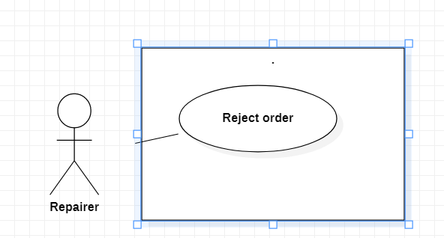

|  |  |  |  |
| --- | --- | --- | --- |
| USE-UC029 | | | |
| Use Case No. | UC029 | Use Case Version | 1.0 |
| Use Case Name | Reject order | | |
| Author | LongNLT | | |
| Date | 03/04/2021 | Priority | Medium |
| Actor: - Repairer Summary: - This use case is for repairer who want to reject customer's order Goal: - Repairer reject an order Triggers: - Repairer press reject Precondition: - User must be a Repairer Post Conditions: - Success: Reject and delete the out-going order Main Success Scenario: | | | |
| Step | Actor Action | System Response | |
| 1 | Repairer view the list of on-going order | Display list of on-going order | |
| 2 | Repairer Press the Reject button next to an order | Show a list of reasons why he/she reject the order | |
| 3 | Repairer choose the reason to reject | Select reason | |
| 4 | Repair press confirm | System will show repair service [Alternative Scenario 1] [Exception 1] | |
| Alternative Scenario: | | | |
| Step | Actor Action | System Response | |
| 1 |  |  | |
| Exceptions: | | | |
| Step | Actor Action | System Response | |
| 1 |  | System show message the "System is busy" when the internet is lost | |
| 2 |  | System show message the "Not found" | |
| Relationships: N/A Business Rules: - Search request will be sent to the system. | | | |

# NON-FUNCTIONAL Requirements

## Usability

Repairer, Admin should need less than one day of training to be  
productive with the system.

## Reliability

A reliable application is one that meets the needs and expectations of everyone it serves. While those needs and expectations will vary from case to case, reliability is characterized by the ability of an app to: be accessible when needed and respond within the time frame needed. Our app guarantees all of that.

## Performance

The application’s load time should not be more than one second for users.

## Supportability

The application is design that it can be maintainable and extensible.

## Design Constraints

The application supports 2 main languages: Vietnamese and English.

The application is unified in selecting only 2 to 3 different programming languages and 1 type of structure to facilitate debugging and updating.

# Supporting Information

N/A